Ansible Assignment 1

## Ansible Setup



## AWS EC2 Setup

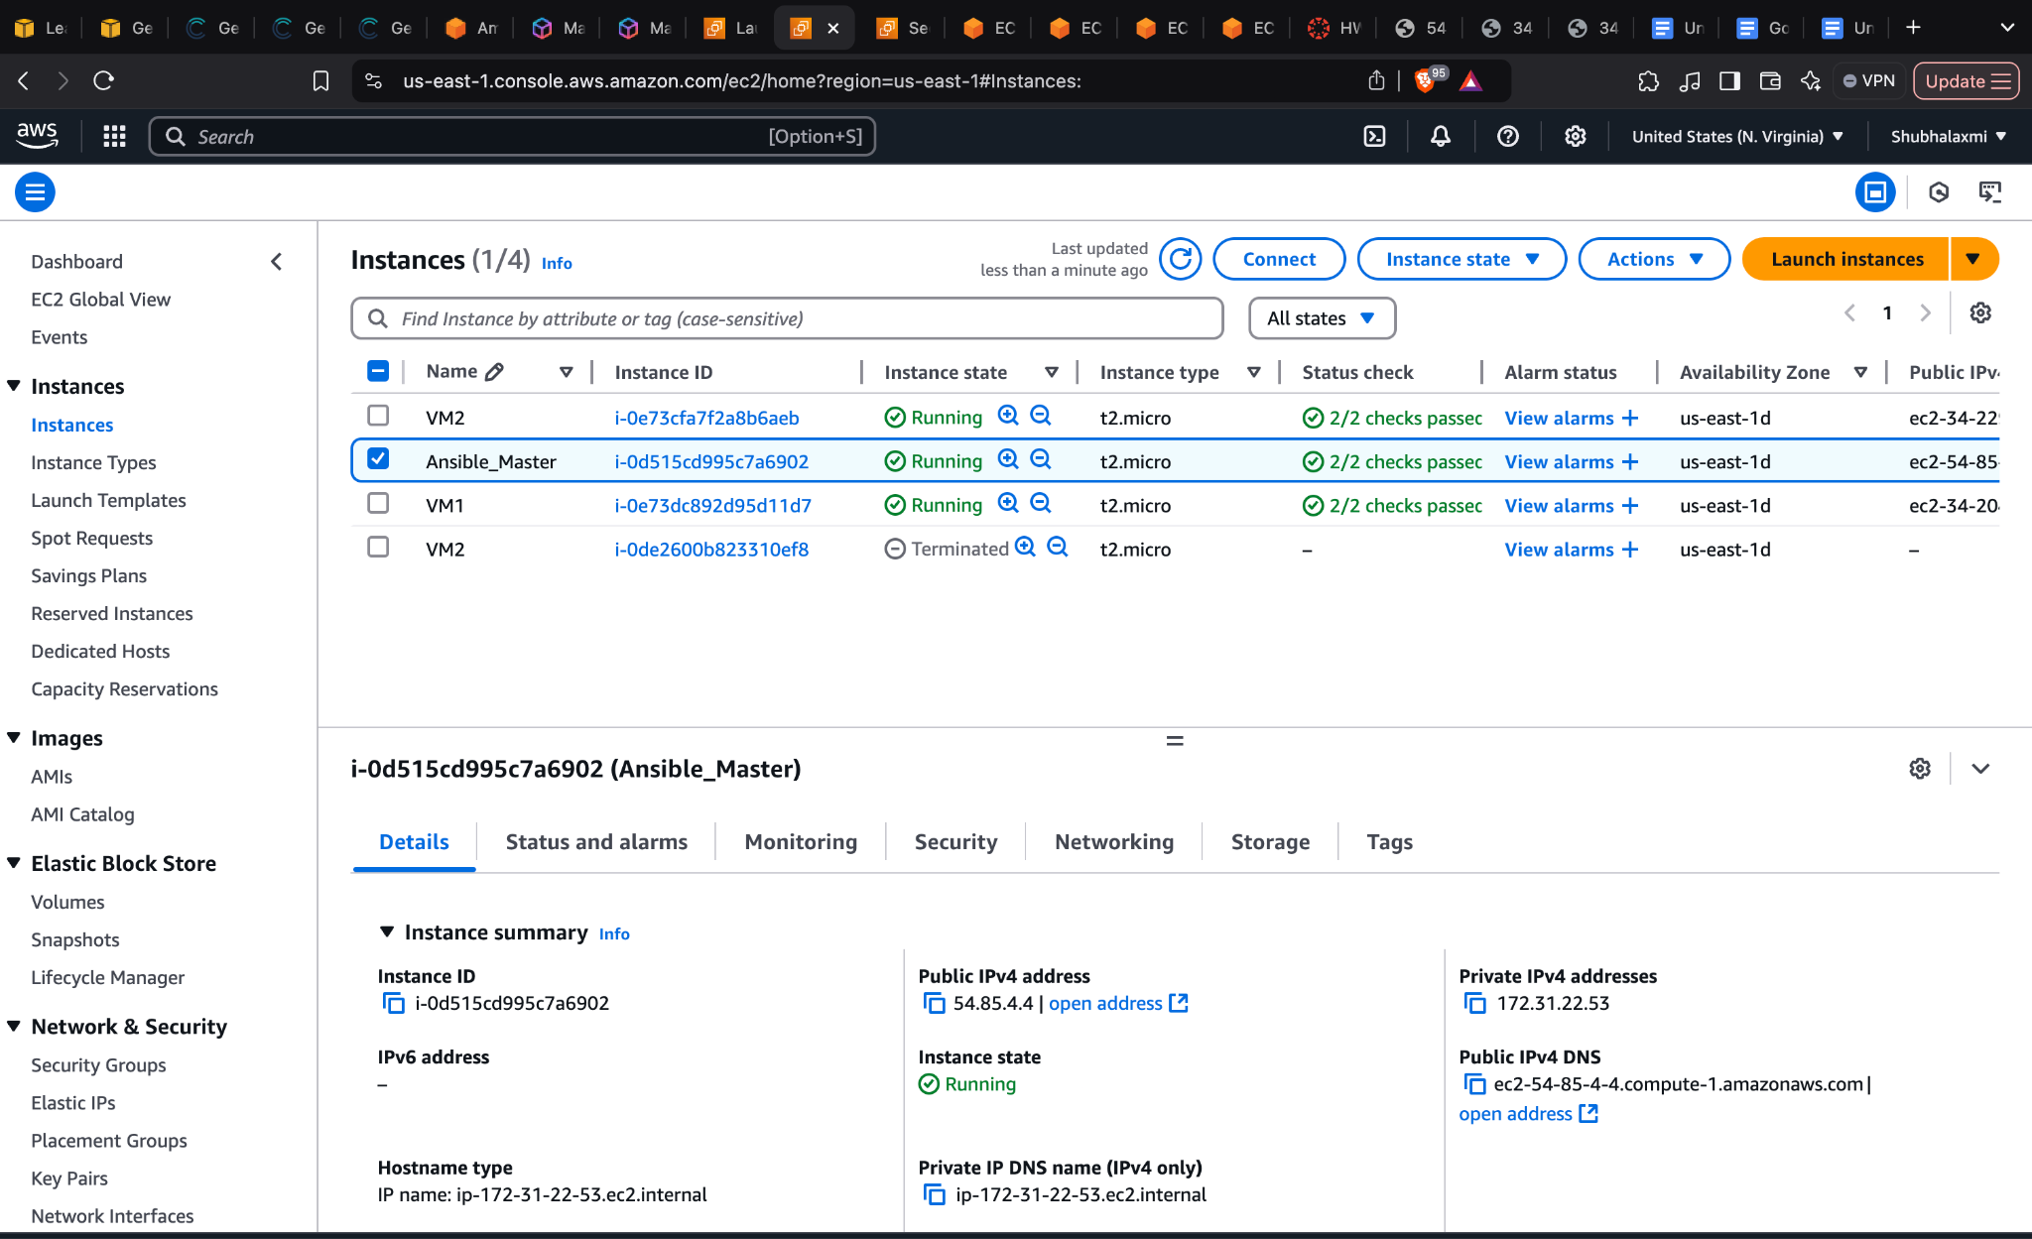

## Steps

* **Launch three EC2 instances in the AWS Console:**
  + One as Ansible control Server
  + Two for Web Servers (VM1 and VM2)
* **Configure inbound rules for VM1 and VM2:**
  + Allow incoming HTTP traffic on port 80.
  + Allow SSH access as needed.
* **Set Up SSH Access**
  + Login to each EC2 instance.
  + On the Ansible control node, add the private key from Step 1 to **~/.ssh/ansible_key** and ensure it has the correct permissions (chmod 600 ~/.ssh/ansible_key).
* **Configure Ansible Inventory**
  + In the Ansible Server, create a file /etc/ansible/hosts and add the public IP addresses of VM1 and VM2.
  + Set ansible_ssh_private_key_file=~/.ssh/ansible_key so that the Ansible Server can find the correct private key to establish an SSH connection to its nodes.
* **Create an Ansible playbook to do the following tasks** 
  + Install Nginx
  + Change the default Nginx port to 8080
  + Deploy index.html
  + Restart Nginx Server
* Run the Ansible playbook and verify if the web pages are accessible via the public IP
* **Finally, create an Ansible playbook for cleanup**
  + Stop the Nginx service.
  + Uninstall Nginx.
  + Clean up configuration files if necessary.
* **Execute the playbook to remove Nginx from all servers and verify.**

## Ansible PlayBook

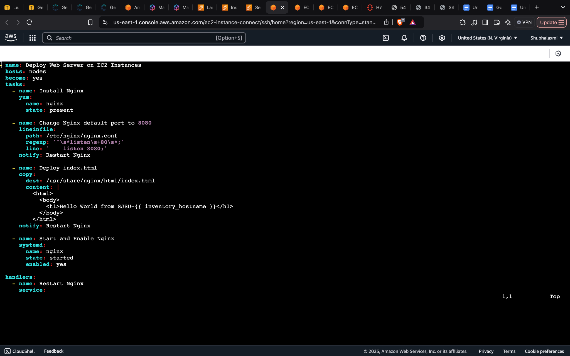

### 

### Commands Used for Playbook Deployment

| $ **ansible-playbook deploy_webservers.yml** |
| --- |

### Deploy Output

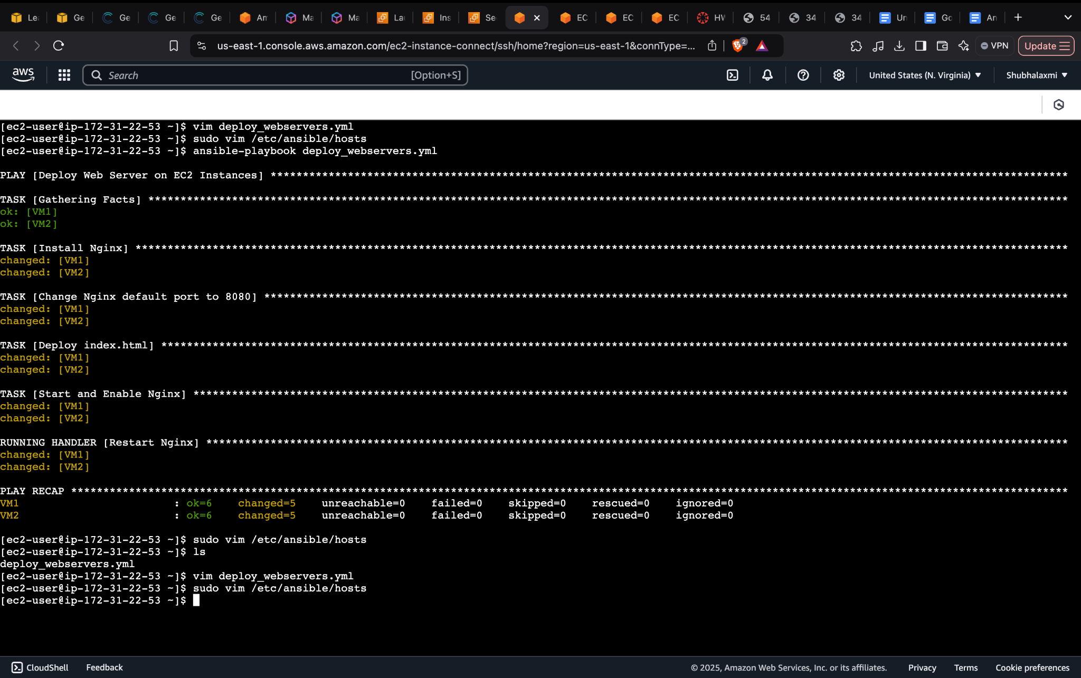

### Verify that Nginx is Running

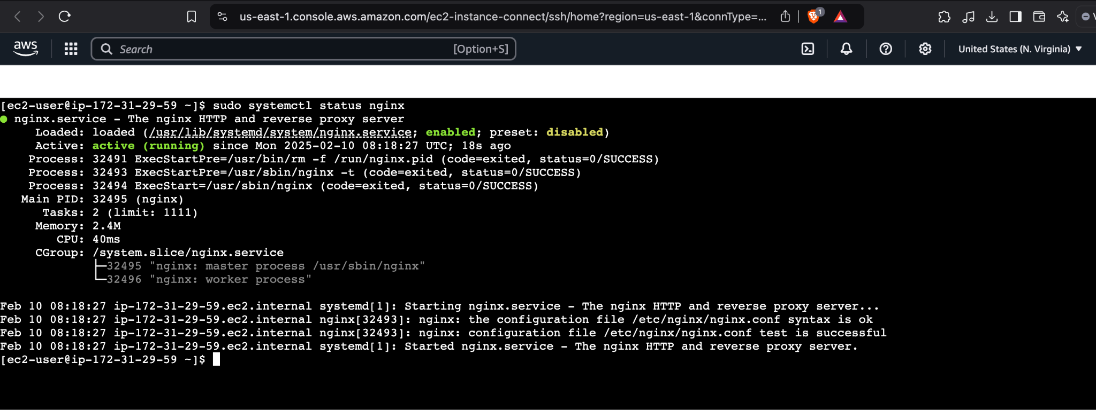

### VM1 Webpage Output

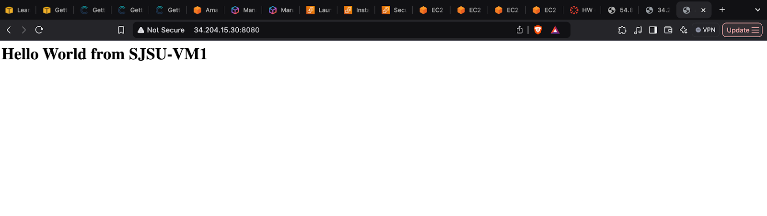

### VM2 Webpage Output

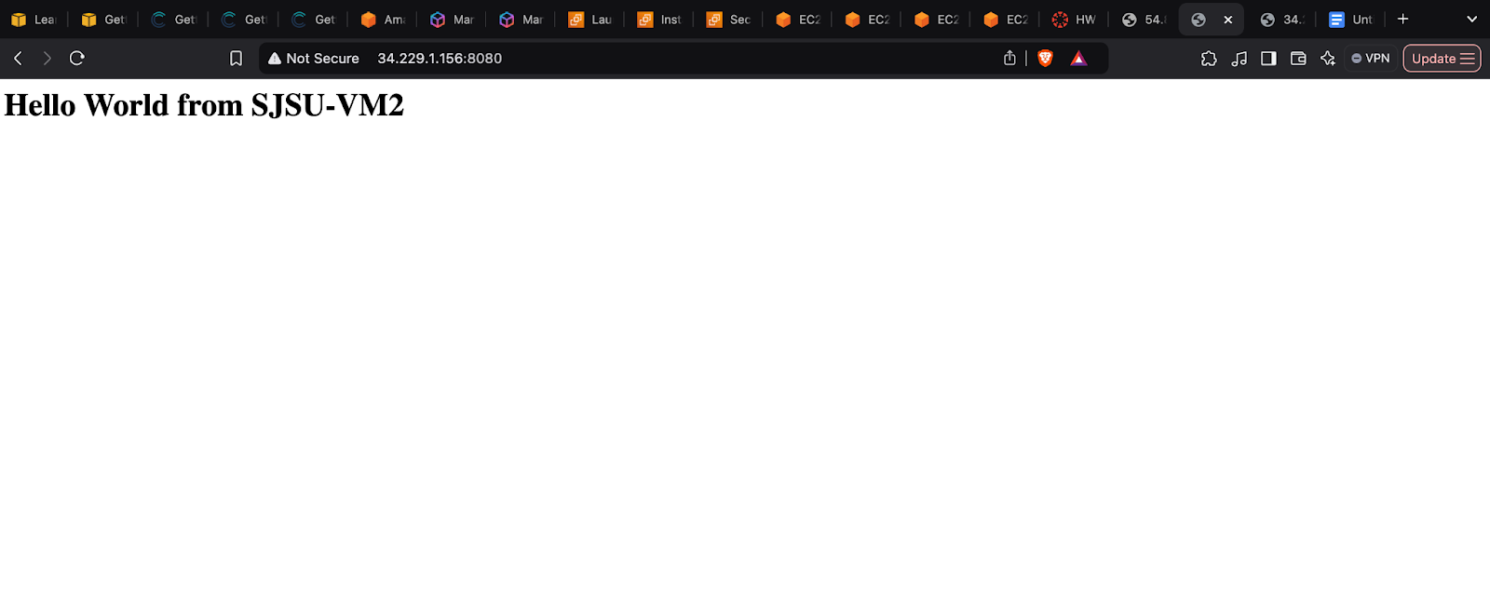

Ansible Playbook for removing the deployments

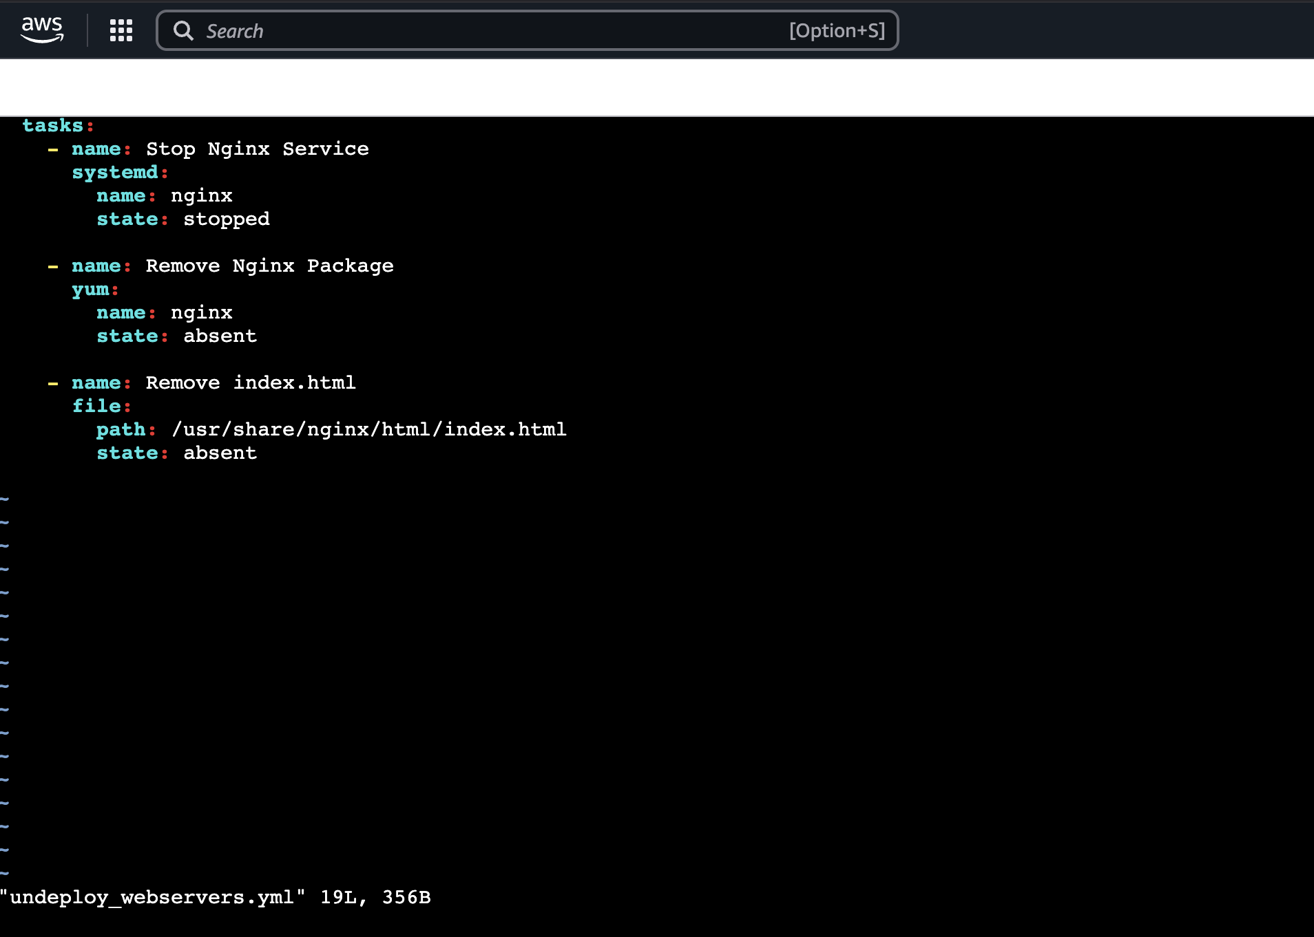

### 

### Command Used to remove the deployment from all VMs

| **ansible-playbook undeploy_webservers.yml** |
| --- |

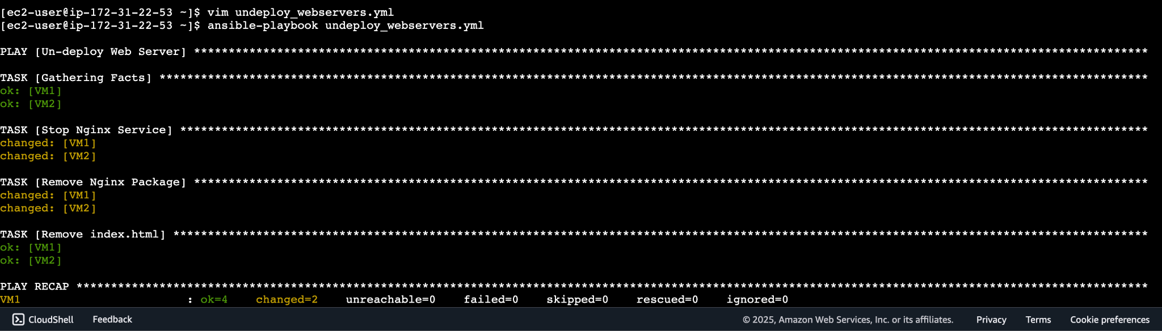

### Verify that Nginx is stopped

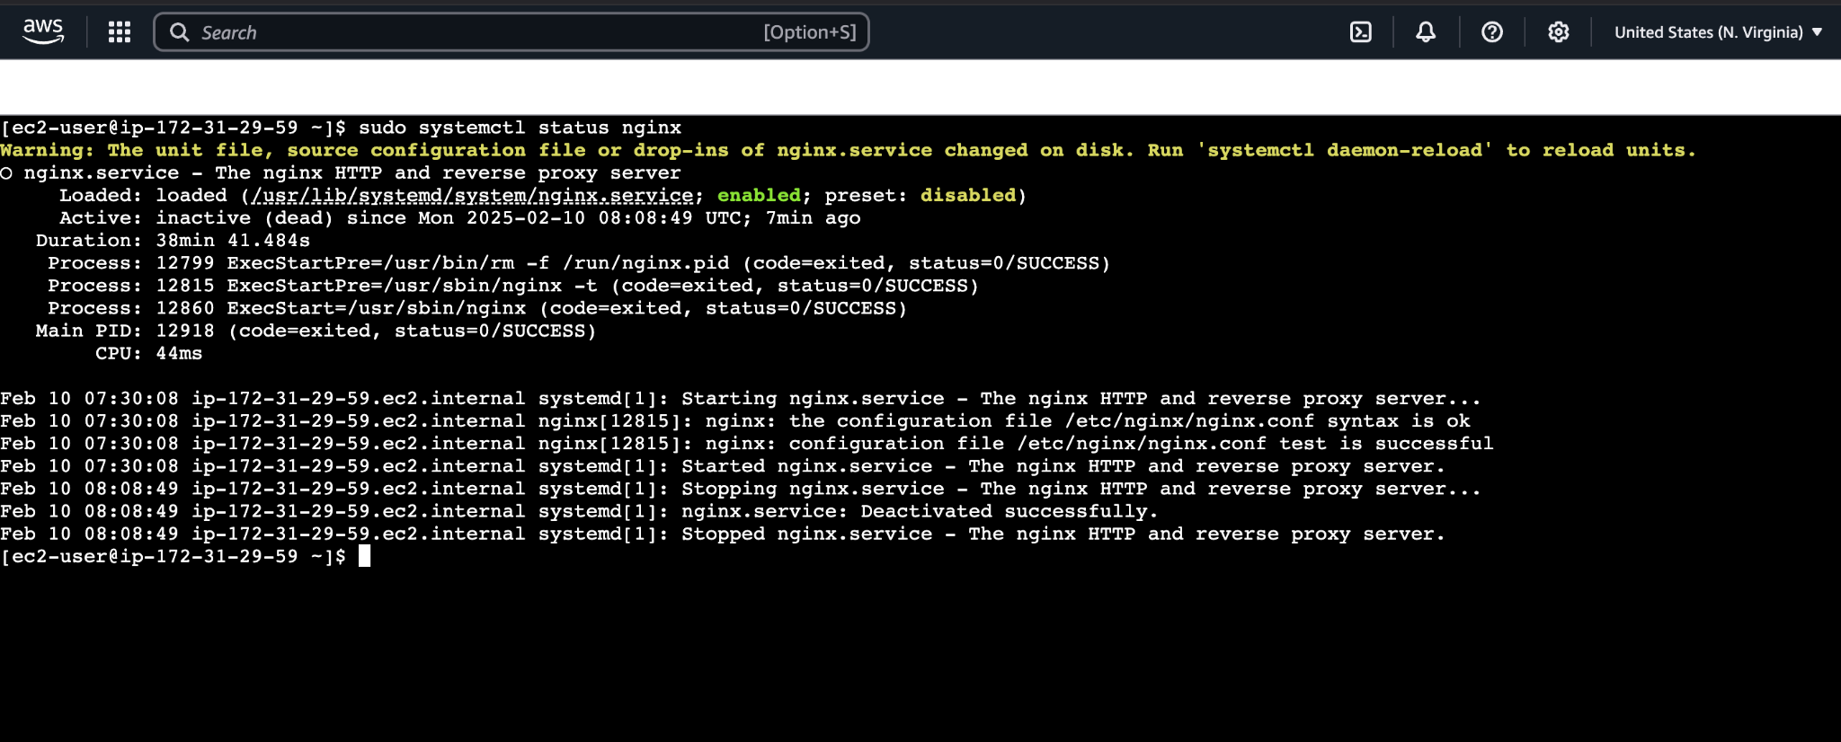

## Hosts file in Ansible Server

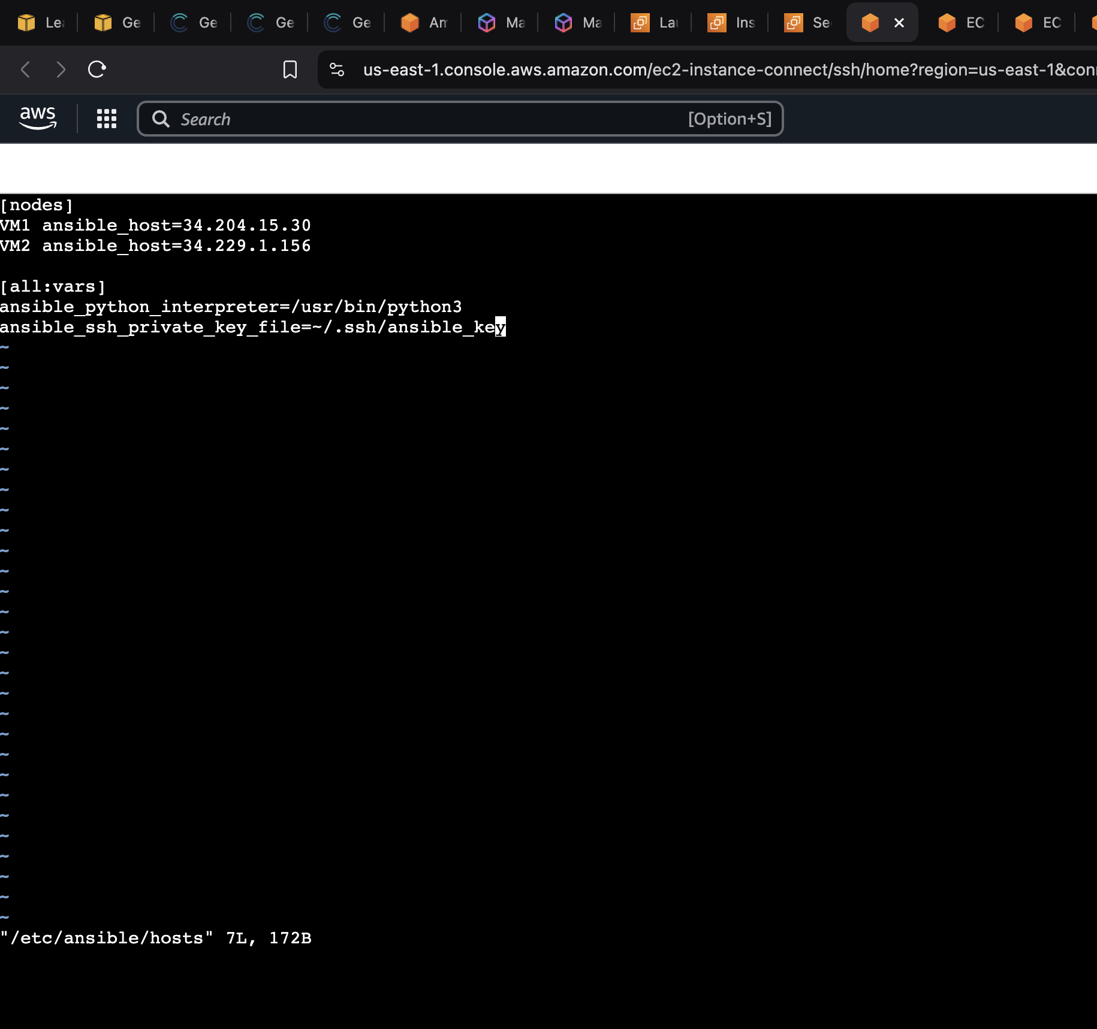

## Links

[GitHub Link](https://github.com/bhusalashish/Ansible_Assignment)

<https://github.com/bhusalashish/Ansible_Assignment>